Account admin :

+ username : admin

+ password : admin

Account user :

+ username : quannd

+ password : 123

**1. Login guild**

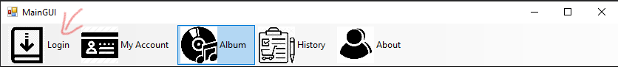

**2.SignIn**

Click Login first then click SignUp

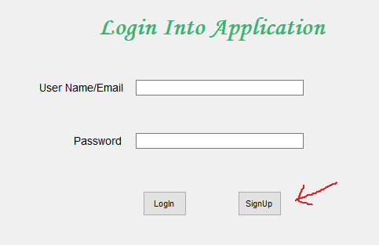

**3. CheckOut**

Login with user account

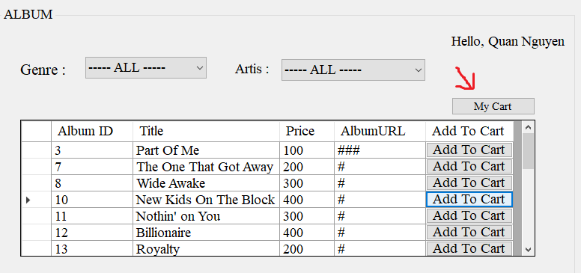

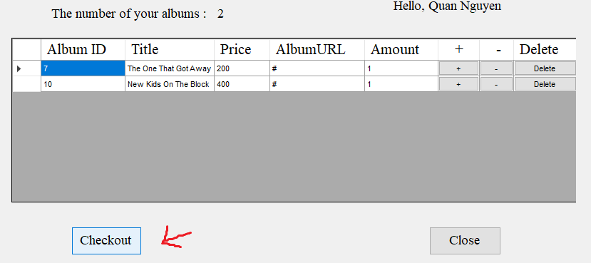

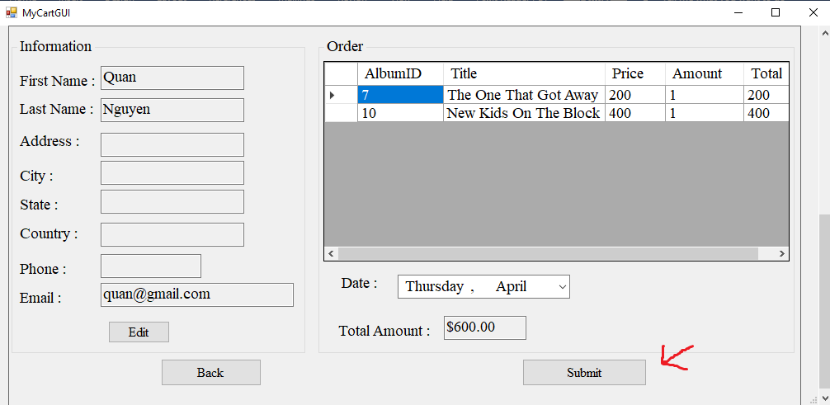

**4.Logout**

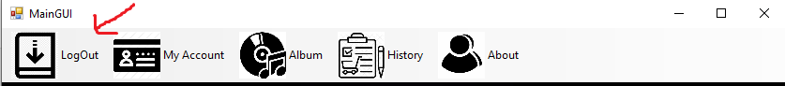

**5.Manage Album**

Login with Admin user

